2026 Red Apple Grant Recipients
Learn more: warsawedfoundation.org/redapplegrant

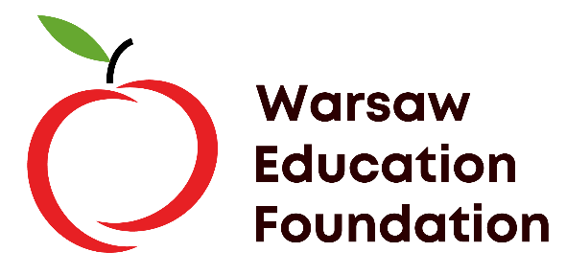

Teacher Name | Building | Grant Amount | Project
Kristi Lucht | Claypool Elementary | 1303.00 | K-6 Sphero Bolt+ Coding Project
Abbi Richcreek | Edgewood Middle | 1500.00 | Tag It!
Emily Gough | WCHS | 1235.01 | Dissolved Oxygen Probes for Science Labs
Loren Schaefer | WCHS | 1500 | Weather Station
Alexi Demopoulos | Edgewood Middle | 1476.71 | Safely Shreddin’ the Trails
Catherine Cavanaugh & Leah Kilgore | Lincoln Elementary | 1345.30 | Little Listeners, Big Learners: Yoto Players for Growing Minds
Bethany Anderson | Washington Elementary | 1000.00 | Buddy Bench
Michele Beam | Lincoln Elementary | 1425.00 | Read & Rock
Lydia Campbell | Washington Elementary | 1425.00 | Translator Earbuds
Kelly Basalo | Jefferson Elementary | 1441.25 | Brewing Kindness: Students Connecting Learning & Service
Tracy Berger | Gateway | 1062.31 | Cards & Craft Business

